**YOUR HEALTH RESOURCE**

**Health Education England** (NHS) and **The Reading Agency** have worked in partnership to bring together a list of books and digital resources called ‘Your Health Collection’, to support users to manage their health better and live well.

**BOOKS**

<https://tinyurl.com/y3smcpcc>

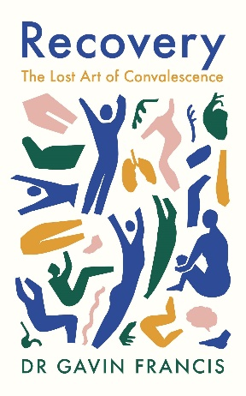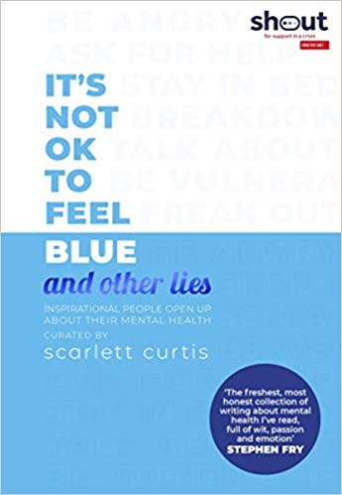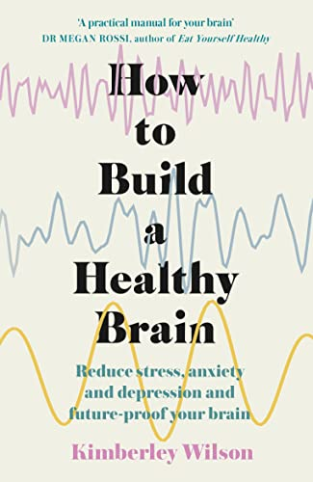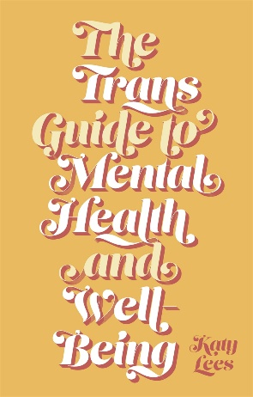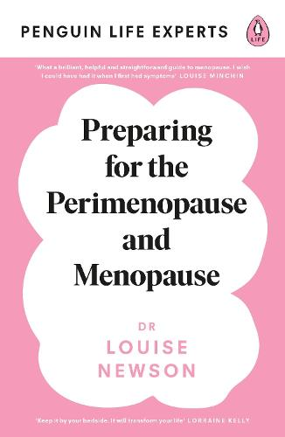

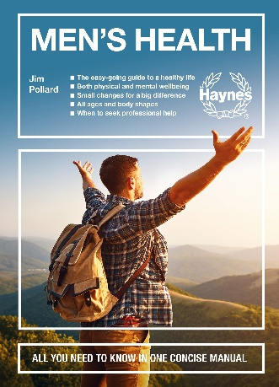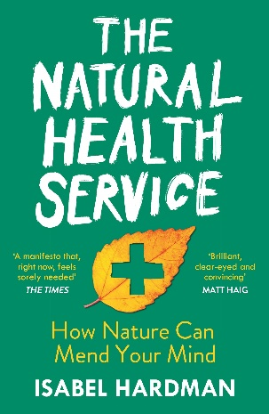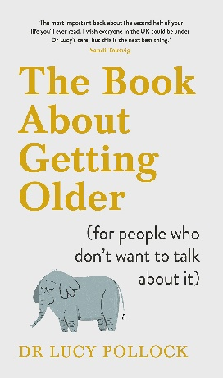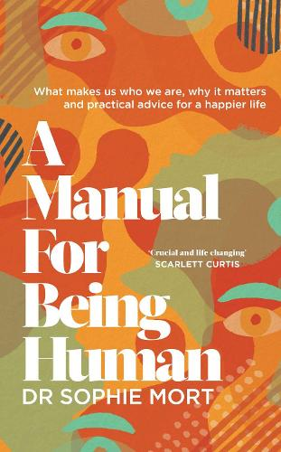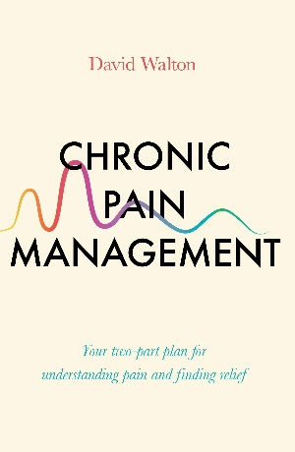

**DIGITAL RESOURCES**

<https://library.nhs.uk/yhc/>

* NHS
* Patient
* Royal College of Psychiatrists – Problems & Disorders
* Scope
* The Sleep Charity
* Spark
* St. John’s Ambulance
* **Switchboard – LGBT+ helpline**
* Terrence Higgins Trust
* Age UK
* Alzheimer’s Society
* Balance – Menopause Library
* Blurt
* Carer’s UK
* Easy Health



* Health Talk
* Mind

**Tweet - @smallwoodlib**

[**smallwood.library@nhs.net**](mailto:smallwood.library@nhs.net)